**DIRECT CURRENT CIRCUITS**

Any combination or interconnection of electrical devices (i.e. conductors, resistors, sources, capacitors, etc) which form a continuous path for electrical current is called an **electrical circuit**.

*Types of Electrical Circuits*

**Direct Current (DC) Circuit** - current flows in only one direction all the time.

**Alternating Current (AC) Circuit** – current flows in an alternate direction several times per unit time depending on the frequency.

**RESISTORS IN SERIES AND PARALLEL**

**Resistor –** an electrical component whose primary function is to provide resistance of a certain value (limits the current flow)

**RESISTORS IN SERIES**

Resistors are connected in series when one and only one terminal of a resistor is connected directly to one and only one terminal of another resistor.



(***current can follow only one path*** as it flows through two or more resistors connected in line)

*Circuit Characteristics:*

1. The current through each resistance is the same as that through all the others.

**ITOTAL = I1 = I2 = I3 = …**

1. The potential drop (voltage) across the combination is equal to the sum of the individual potential drops.

**VTOTAL = V1 + V2 + V3 + …**

1. The equivalent resistance (total resistance) is equal to the sum of the individual resistances.

* In series combination, *equivalent resistance is always greater than the largest of the individual resistances*.

**RTOTAL = R1 + R2 + R3 + …**



**RESISTORS IN PARALLEL**

Several resistors are connected in parallel between two nodes if one end of each resistor is connected to one node and the other end of each is connected to the other node.

*Circuit Characteristics:*

1. The total current entering the combination is equal to the sum of the individual branch currents.

**ITOTAL = I1 + I2 + I3 + …**

1. The potential drop V across each resistor is the same as the potential drop across each of the others.

**VTOTAL = V1 = V2 = V3 = …**

1. The equivalent resistance is such that its reciprocal is equal to the sum of the reciprocal of the individual resistances.

* In parallel combination, *the equivalent resistance is always less than the smallest of the individual resistances.*

$\frac{1}{R_{TOTAL}}$**= $\frac{1}{R_{1}}$ + $\frac{1}{R_{2}}$ + $\frac{1}{R_{3}}$ + …**

**Sample Problems**

1. 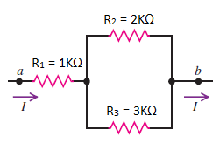Determine the Equivalent (Total) Resistance of the following circuits.

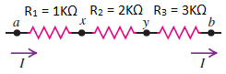

1. c.

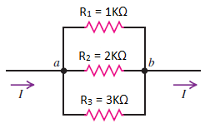

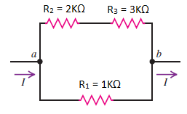

1. d.
2. Find the equivalent resistance of the network as well as the voltage and the current in each resistor. Determine the power delivered by the battery and the power dissipated at each resistor.

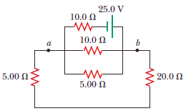

1. The figure shows a multiloop circuit containing one ideal battery of unknown emf and four resistances. Determine the (a) current at R3, (b) total resistance, (c) total current, and (d) the emf of the battery.

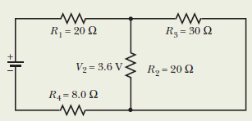

**KIRCHHOFF’S LAWS**

**Kirchhoff’s Current Rule (KCL) or Junction Rule**

* The sum of all the currents coming into a node (i.e., a junction where three or more current-carrying leads attach) must equal to the sum of all the currents leaving that node.

$$\sum{I=0}$$

*(The algebraic sum of the currents into any junction is zero.)*

* A **junction** in a circuit is a point where three or more conductors meet.

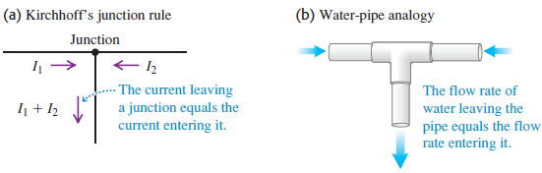

**Kirchhoff’s Voltage Rule (KVL) or Loop Rule**

* As one traces out a closed circuit, the algebraic sum of the potential changes encountered is zero. In this sum, a potential rise is positive and a potential drop is negative.
$$\sum{V=0}$$

* A **loop** is any closed conducting path.

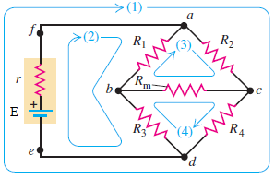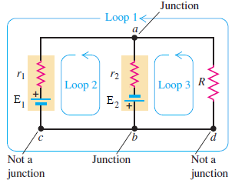

Sign conventions:

* 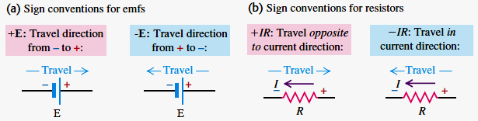Current flows from high to low potential through a resistor. As one traces through a resistor in the direction of the current, the potential change is negative because it is a potential drop. The positive terminal of a pure emf source is always the high-potential terminal, independent of the direction of the current through the emf source.

**Sample Problems**

1. In the circuit shown, find the current in each branch.

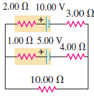

1. Find the current through each of the three resistors of the circuit shown. The emf sources have negligible internal resistance.

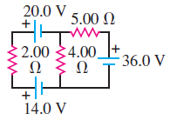

1. In the circuit shown, both batteries have insignificant internal resistance and the idealized ammeter reads 1.5A in the direction shown. Find the emf, E of the battery.

